***Website Documentation***

1. **Category**: All the category added by admin and instructor will be listed in the homepage.

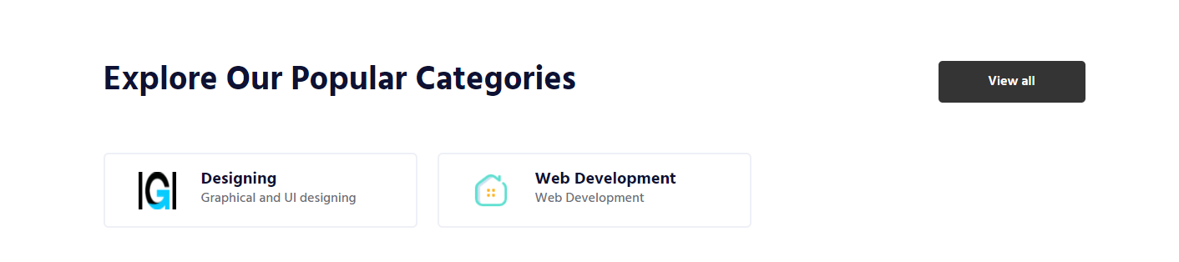

1. **Latest Course**: All the courses added by admin and instructor will be listed in the homepage.

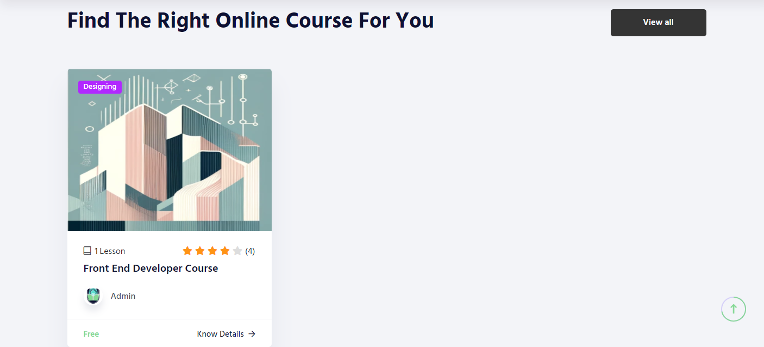

1. **Course List**: All the latest course will be listed below once user will click on the view all button.

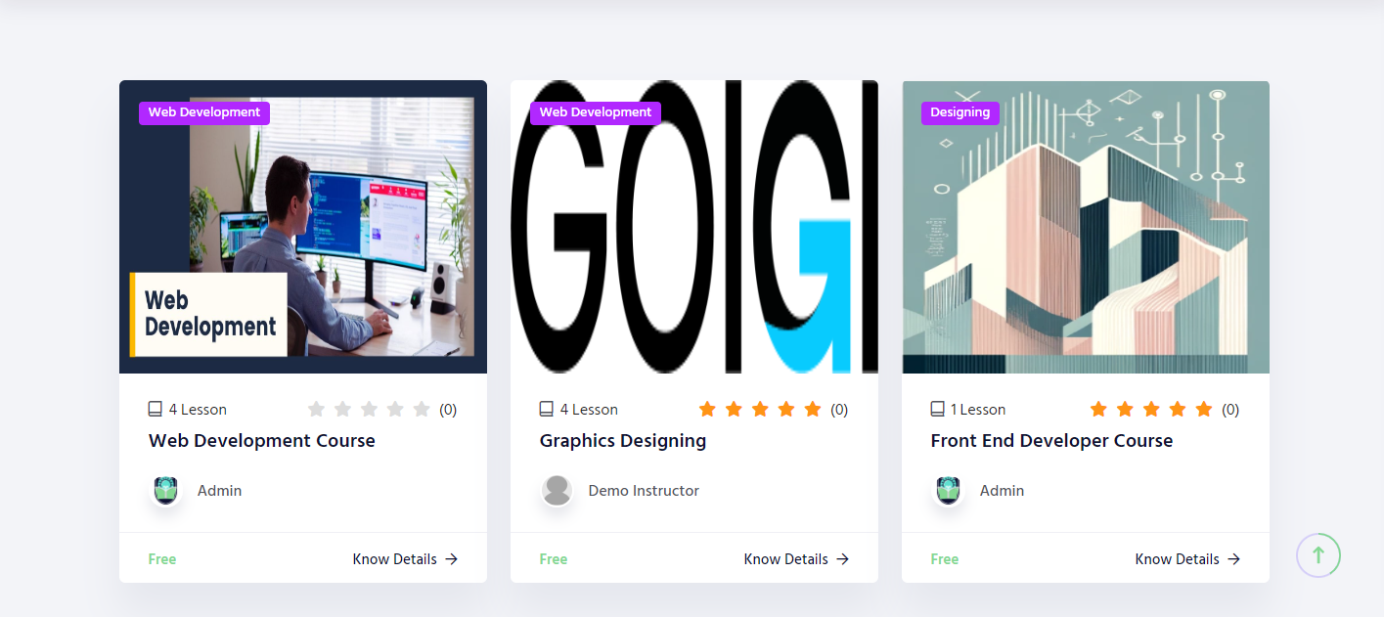

1. **Course Details**: Once user click on any course, it will redirect user to details page All the related content will be reflect in the course detail s page.

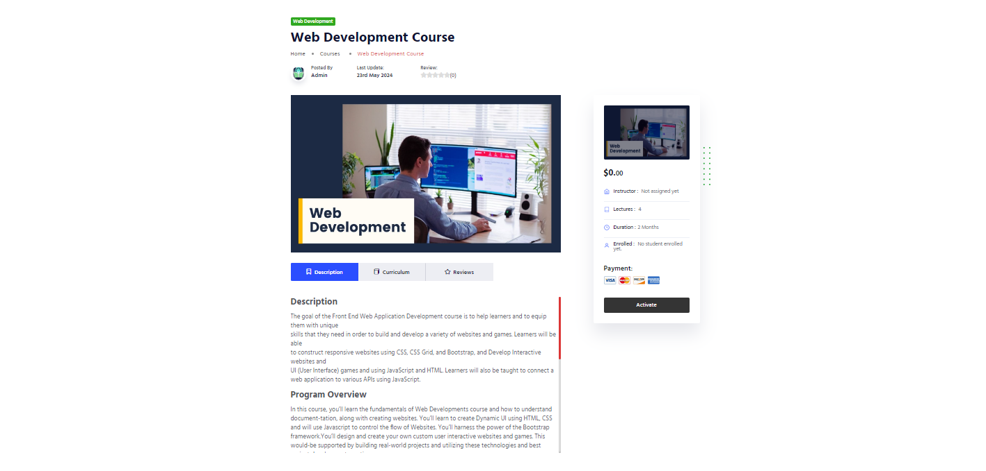

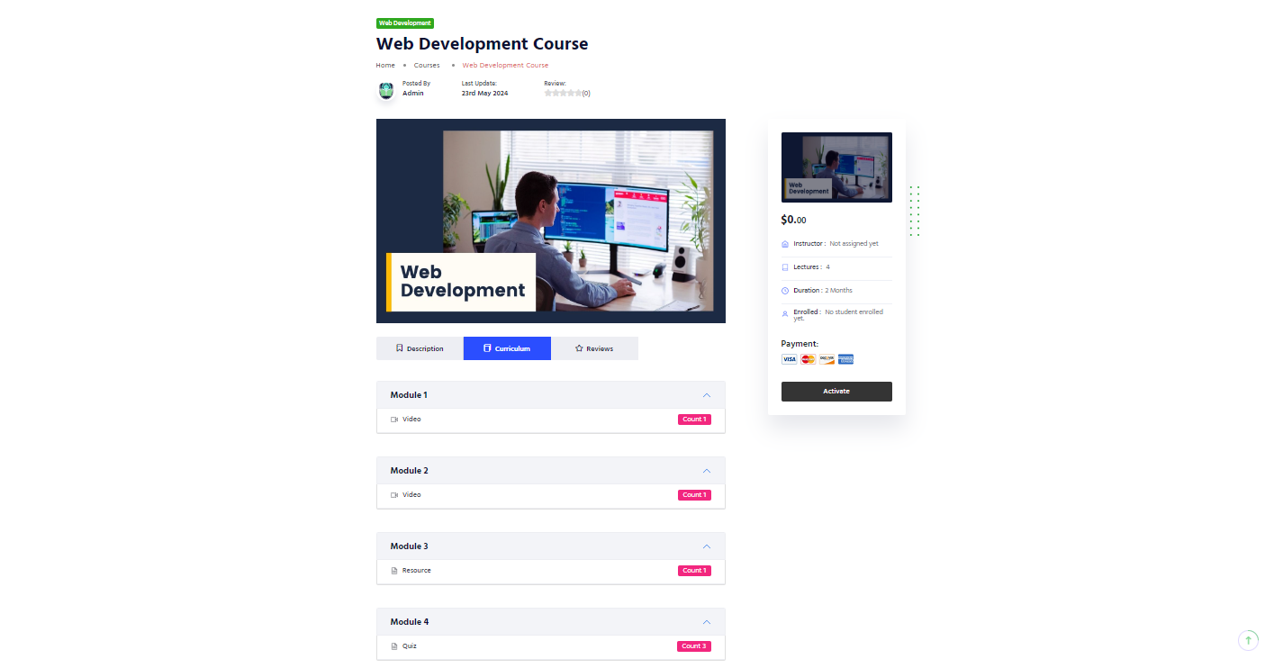

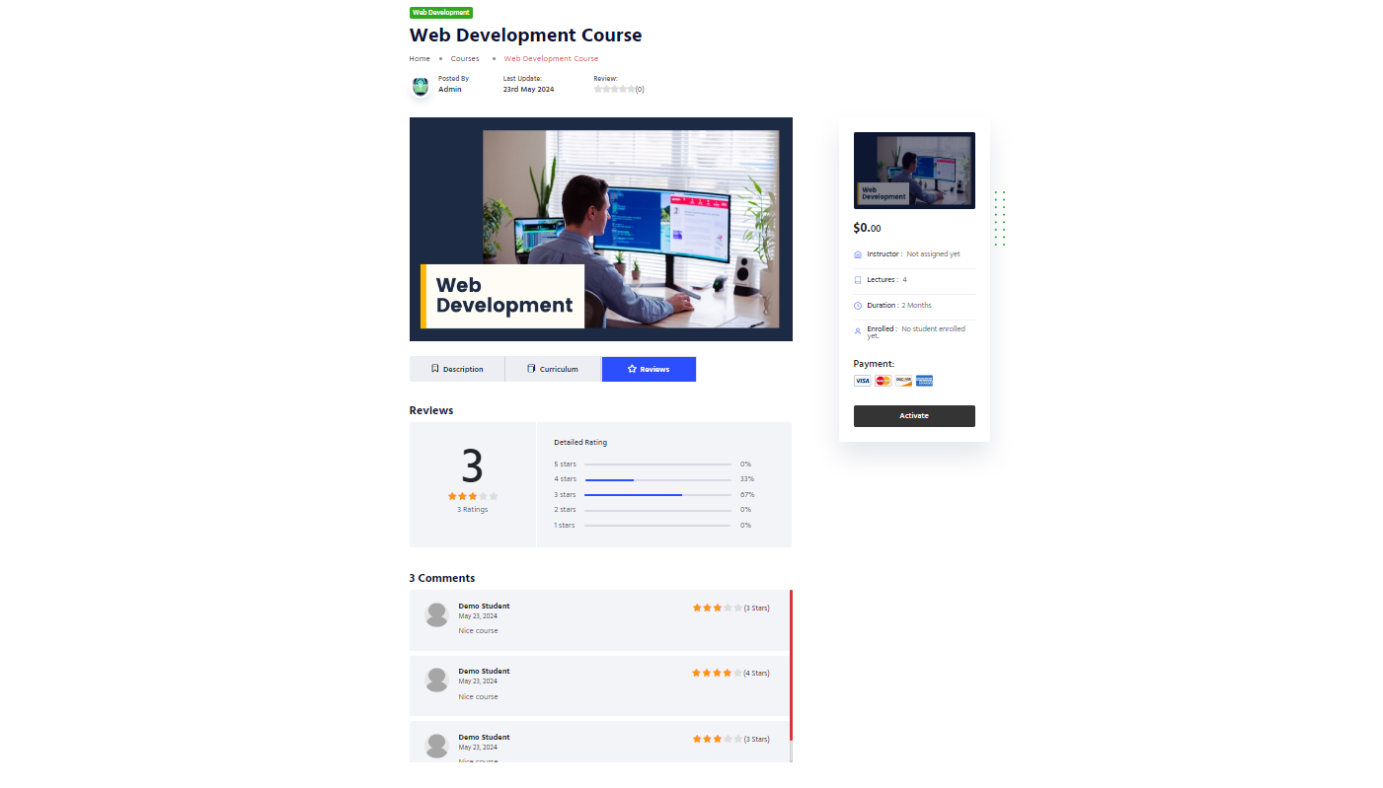

1. Activate Course: Student need to purchase course to access the content. All the purchased courses will be listed in the student dashboard after student login.

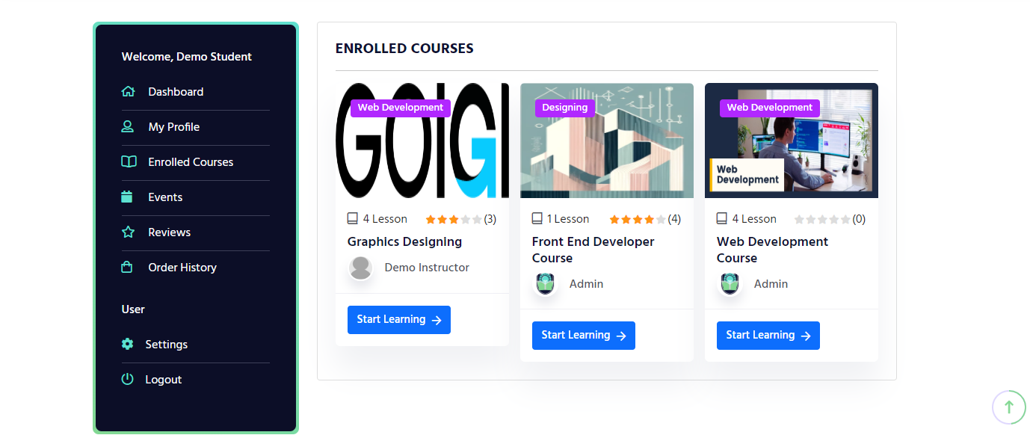

1. Student Profile: Update student profile.

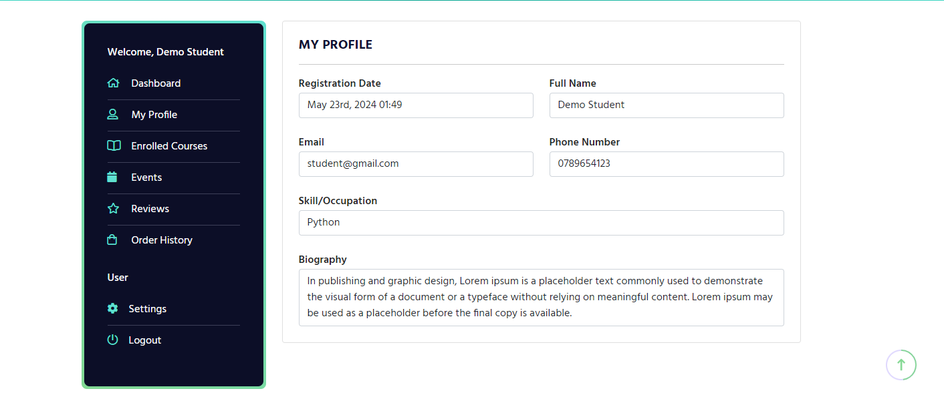

1. Joined Event:

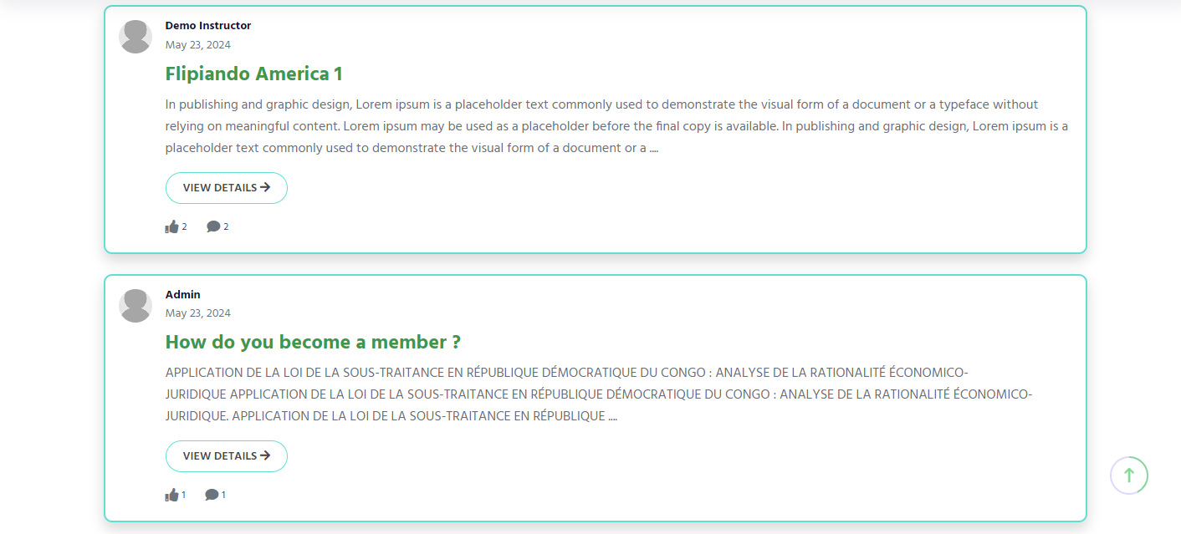

Click on the view details it will redirect user to the community details page. Where user can post comment and like and join an event.

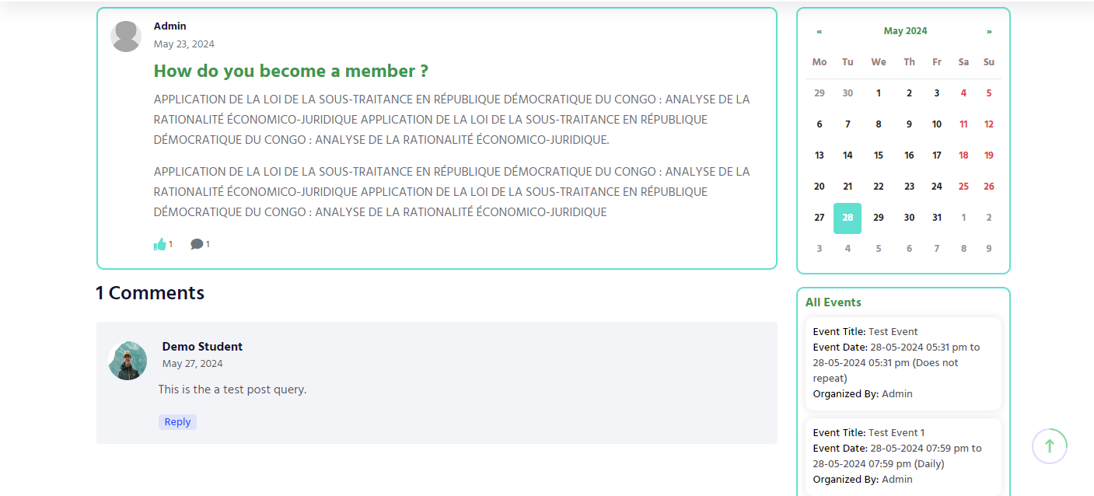

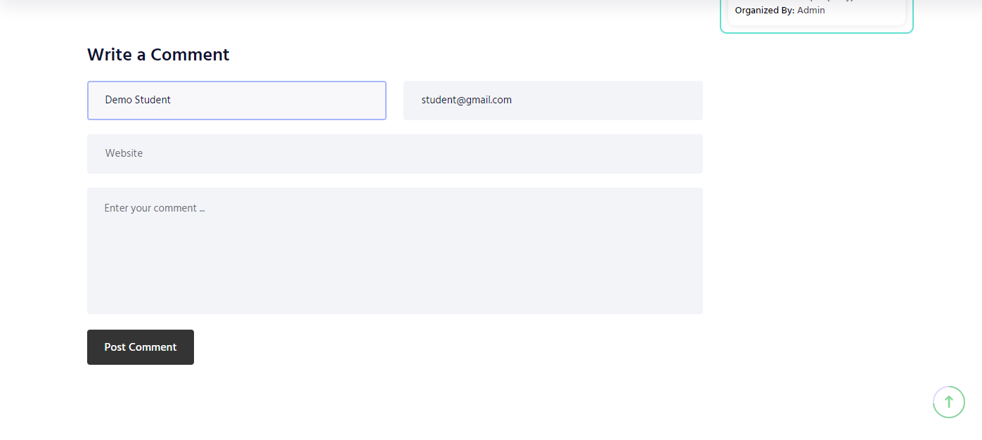

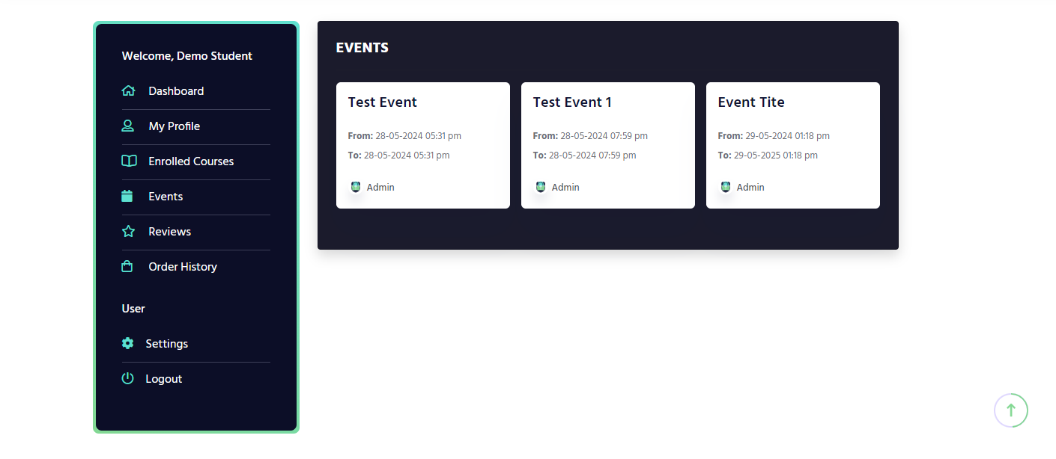

***NOTE: All the data showing in the screenshot are taken from development server.***